Poster
>>>>>>>>>>>>>>>>>>>>>>>>>>>>>>>>>>>>>>>>>>>
In the format for the submission for Advances in Biology Laboratory Education

Revisiting Mendel: Use of a behavioral assay to examine inheritance of traits in Drosophila

Jeffrey M. Chalfant¹, Robin L. Cooper², Tawny Aguayo-Williams¹ Lexie Holtzclaw³, Madison Loveless³, Jennifer Wilson³, and Doug Harrison²

¹Dept. of STEM, Univ. of KY., Lexington, KY.
²Dept of Biology, Univ. of KY., Lexington, KY.
³Pulaski County High School, Somerset, KY

Using the established rules of Mendel and others, predicting the outcome of genetic crosses in model organisms is a common exercise for college students. Frequently, one uses visible phenotypic markers such as curly wings, eye color, and abnormal bristles to identify genetic outcomes. Yet many genetically-based traits, such as behavioral and physiological characteristics, are not easily observed. To demonstrate that such traits can likewise display classical genetic inheritance, we utilized an optogenetic system in Drosophila to modify response to light. We utilized the inheritance of behavioral responses associated with light-activated channelrhodopsin in motor neurons and body wall muscles. The frequency of responsive animals was quantified over multiple generations beginning with two pure-breeding (homozygous) strains, each containing one of the two components needed to produce the light-sensitive proteins. The use of light-sensitive channels to examine the predicted genetic outcomes is an approach which can be used in teaching classical genetic principles using non-traditional phenotypes. Green fluorescent protein (GFP) can be expressed to illustrate which cells are expressing channel rhodopsin. This introduces concepts of transgenesis, genetically-modified organisms, and genetic contributions to behavior. In addition to basic dominant and recessive allelic relationships, the experiments introduce more complex genetic concepts, such as epistasis, gene expression and cellular diversity, as well as physiological and behavioral traits of animals. This module is presented in a variety of ways depending on equipment availability, and can be used in a hybrid or remote format with data provided.

Keywords: genetics, problem-based learning, behavior, optogenetics, asynchronous learning, hybrid

Introduction
The fundamentals of genetics are generally taught with simple dominant and recessive alleles controlling a phenotype with distinct and discrete alternative forms. Examples often begin with classical Mendelian observations such as round vs. wrinkled pea shape and yellow vs. green pea color. “True-breeding” homozygous (two copies of the same allele) strains displaying alternative phenotypes are interbred to show dominance of one allele in the heterozygous (one copy of two different alleles) first offspring (F1) progeny. Carrying the trait to a second generation (F2) by intercrossing the F1 progeny and quantifying the phenotypic classes illustrates the heritability of the traits, and exposes the underlying genotypic basis of the phenotypes.
Drosophila (fruit flies) are commonly used in high school and college level courses to illustrate heritability in a Mendelian approach with homozygous and heterozygous alleles. Generally, simple visible traits are used, such as eye color, length of bristles or shape of the wings. Yet, the vast majority of genes regulate traits for which there is no overt directly observable effect. In this module, we demonstrate that more complex traits, including behaviors, can also display inheritance patterns rooted in fundamental Mendelian concepts. In one experiment, a transgenic construct that directs expression of the jellyfish green fluorescent protein (GFP) in all muscles can only be observed under appropriate conditions, namely blue excitatory light. The trait will be inherited as a simple dominant allele, yielding predictable ratios in outcrossed animals. In the second experiment an optogenetic system expresses channelrhodopsin, a light-sensitive ion channel from algae, to activate motor neurons or body wall muscles in the fly larvae. Upon light stimulation, activation of channelrhodopsin results in a rapid and reversible paralysis that can be easily scored. The expression of channelrhodopsin is dependent on the presence of two separate transgenes, a GAL4 driver expressed in either motor neurons or muscles and a UAS-channelrhodopsin responder that encodes the optogenetic protein (see Markstein, 2018 for general description of GAL4-UAS system). Only one copy of each transgene is needed, therefore each is dominant. However, both transgenes are needed to complete the expression system, therefore they display genetic epistasis (the phenotype of one gene’s alleles is dependent on another gene’s alleles). By crossing fly lines separately carrying each transgene, predictable inheritance of light-sensitive behavior can be elicited.
The use of optogenetic manipulation permits controllable activation of neurons, so one can regulate predictable behaviors in response to light. Selective expression of optogenetic tools, such as channelrhodopsin, is used in research to understand neuronal wiring and the relationships of specific circuits to defined behaviors. Optogenetics also has the potential to be used as a therapeutic regulator of neuronal circuits, which can be applied to models such as fruit flies to provide a proof of concept.
To further illustrate that genes exhibit different patterns of expression in distinct cell types, additional test crosses may be performed using the visual identification GFP expressed in different tissues. By using different GAL4 drivers with distinct cell type specificity, students can observe fluorescence in body wall muscles, motor neurons, sensory neurons, or heart. By using the same GAL4 drivers used in the quantitative crosses, students will also be able to relate the tissues affected with the optogenetically-derived behavioral phenotypes observed.

Student Outline
Objectives
Students will learn:
- Students will be able to see selective tissue expression of GFP
- Students will be able to explain Mendelian inheritance of genetic traits by examining associated behaviors to controlled stimuli.
- Students will be able to explain what a transgenic organism is.
- Students will be able to form hypotheses on how optogenetics can be used to manipulate locomotion in Drosophila melanogaster larvae.
- Students will be able to describe practical applications of biotechnology, particularly optogenetics.

Protocol

Safety and Initial Set-Up for Experimental Phase

- The LEDs are very bright light and can damage your eyes. DO NOT look directly into the LED or shine onto other people.
- The ATR (all-trans retinal) is a compound that can absorb through skin. DO NOT get on your skin. If you do come into contact, wash with soap and water as soon as possible. It will not burn your skin but absorption into the body should be avoided.

Procedure for Experimental Phase
Procedure for Experimental Phase
- Inheritance of a single GFP transgene
- Confirm the visibility of GFP using the available fluorescence observation system. Place a few larvae from the mhc-GFP strain into a petri dish. Illuminate with blue light and use a green filter to view the larvae. Strong fluorescence in the muscles of the larval body should be readily visible, while there should be none in a negative control strain, such as w¹¹¹⁸. If desired, the tissue specific expression pattern directed for each GAL4 driver to be used can also be illustrated by crossing each GAL4 strain with a UAS-GFP strain and observing progeny as above (see accompanying Table 1 for a list of lines and crosses to be made).
- To examine inheritance of the fluorescence trait, cross two parental lines, one homozygous for the mhc-GFP transgene and one lacking the transgene (w¹¹¹⁸). To make controlled crosses, one must obtain virgin females of one parental line and males (they do not need to be virgins) of another parental line. If the instructors make these crosses, they should explain the procedure to the participants. For a learning experience the instructor might have these crosses already made but then allow students to also try on their own. There are many online web sources to help student distinguish males and female Drosophila. An educational module with details on this content is provided as open source (Majeed et al., 2017)
- Several online resources are available to see the differences in males and female adult flies; the presence of black tuft of hairs on the forelegs indicates a male fly. It is good to compare the flies side by side to tell the differences. Virgin females can be obtained by selecting freshly enclosed adults within 4 hours. If freshly enclosed, a green matter (i.e., meconium) is still observed in the intestinal tract close to the anal pore.
- Combine approximately 5 virgin females and 5 males in a vial with fly food. If five of each cannot be collected all at one time, flies may be added to the cross until complete. After about 4-5 days, larvae should be visible crawling in the food or on the sides of the vial. Parent flies may then be discarded or transferred to a fresh vial to generate more F1 progeny, if needed. A few F1 larvae can be removed from the vial to test for fluorescence as in step 1 above. All animals should be heterozygous for the transgene, thus should display fluorescence.
- Allow F1 progeny to eclose as adult flies, then transfer approximately five males and females (no need to collect virgins) to a fresh vial and allow them to produce progeny until larvae begin to crawl on the sides of the vial. Discard or transfer the F1 parent flies from the vial.
- Recover the F2 larvae that remain in the vial by gently rinsing food and larvae from the vial into a petri dish using a water bottle and brush. Transfer larvae to an apple juice plate and do not leave immersed in water, as they will drown.
- Use blue light illumination and observe through green filter to score fluorescence for each larva recovered. Depending on the yield, one may want to set up more than one F1 sibling cross vial to score enough F2 larvae for statistical analysis.

Inheritance of optogenetically-regulated behavior controlled by two transgenes
- As above, crosses of parental strains will need to be performed to assess inheritance patterns. There are many variations in genetic crosses which can be made for this module. The ones we choose to highlight are those that express light sensitive proteins in body wall muscles or motor neurons, as these crosses produce easily observed behaviors in the following generations which will express the gene to make the light sensitive proteins (Majeed et al., 2017).
- The light sensitive protein used in this module is channelrhodopsin. There are different variants to the channelrhodopsin. Some are more sensitive to light than others.
- The line that expresses the light-activated channelrhodopsin-2 in motor neurons is obtained by using virgin females from w*; P{UAS-H134R-ChR2}2 to be crossed with males of D42-Gal4 (BDSC; catalog no., 8816). The H134R-ChR2 is not a highly sensitive line (P{UAS-H134R-ChR2}2, stock BDSC #28995). Crossing virgin females of the ChR2 line (the very light sensitive strain) y1w1118; PBac{UAS-ChR2.XXL}VK00018 (BDSC stock # 58374) (Dawydow et al. 2014) to males of D42-Gal4 (BDSC; catalog no., 8816) will produce F1 generation even sensitive to the white room light. Thus, the F1 need to be maintained in a dark environment. Using virgin females from w*; P{UAS-H134R-ChR2}2 to cross with non-stubble (have to look at hairs in the head. Want long hairs) male 24B-Gal4 (III) (BDSC stock # 1767) will produce F1 generation with weak sensitivity to blue light as the channelrhodopsin will be expressed in heart and body wall muscles. If one wants highly sensitive lines, then express non-stubble males 24B-Gal4 (III) (BDSC stock # 1767) to virgin females of the ChR2 line (the very light sensitive strain) y1w1118; PBac{UAS-ChR2.XXL}VK00018 (BDSC stock # 58374). See Table for specific crossed to various tissue types.
- For control of the blue light on the effect of larvae GFP expression in the same tissue lines, test for ChR2 can be used. So the lines used to show GFP expression can be used to determine if blue light exposure shows a different response then for the ChR2 expression for the same tissue specific expression. For example, cross virgin females UAS-GFP (BDSC Stock # 35786) to non-stubble males (have to look at hairs in the head. Want long hairs) of 24B-Gal4 (III) (BDSC stock # 1767). Test the F1 generation for sensitivity to blue light. See Table for details.
- All-trans-retinal is a cofactor for the channelrhodopsin, which increases the sensitivity to light and increases single channel conductance (Dawydow et al., 2014). ATR (500mg; available from Sigma-Aldrich, St. Louis, MO, USA) is dissolved in 17.6 ml absolute ethanol to make 100mM stock solutions. Then, 100µl of 100mM stock solution is transferred to small tubes, wrapped with aluminum foil and kept in a -20°C freezer. The ATR should be kept away from light. Since it is light sensitive. it will degrade and become ineffective if exposed to light for a prolonged period of time.
- To prepare fly food supplemented with 1mM ATR, 10ml fly food is dissolved in the microwave. The food is left to cool, then 100µl of 100mM ATR is mixed well with the fly food. The food vial should be wrapped in aluminum foil and the food left until well solidified. The larvae to be tested are then transferred from their vial to an ATR-food-containing vial, and are kept in a dark place (to keep the ATR from degradation) at room temperature (22-23°C) for 24 hours before testing.
- If one does not want as sensitive of a F1 generation either use UAS-ChR2H134R-mcherry crosses with ATR feeding crosses or the UAS-ChR2.XXL without ATR feeding. The ATR feeding for the crosses with UAS-ChR2.XXL will make them so sensitive that room white light will activate the channels and a dark adaption time will be required before they will be able to move.
- The percent of F1 larvae responding to light can now be examined.
- The crawling larvae are assessed by placing a group on an apple-juice agar plate. The larvae are left for 10 minutes to acclimate to the new environment and adapt to the dark. Having the room lights off or very dim while the students work is best. The larvae can now be exposed to blue light (470nm wavelength; a dispersed-soda-device can be used, see Majeed et al., 2017).
- Count the number of larvae contracted as compared to the larvae moving in the blue light. Obtain a percent of responsive larvae. Repeat this several times with different groups of F1 larvae.
- Now that the F1 generation are larvae, remove the parental lines. Maybe flip the vial to a fresh vial so all the adults are removed. Allow the F1 to become pupa.
- It is very important to time the newly emerged adults from the pupal cases and flip them into a new vial of food. Let the F1 cross with each other and test their larvae as for the F1 with blue light. Determine the percent of larvae which show behavioral responses to light. Repeat with several different samples of F2 groups.
- Determine the average percent of larvae responding as F1 and F2 generations to light.

In moving larvae, a small paintbrush to transfer larvae to the dish containing the apple juice agar might be suitable. Use paper filter to wick away excess water from the larvae so that movement is not inhibited. Place this dish into the dark area within the cardboard box. Use the LED light to shine the light directly on the dish for 10 seconds. One person in the group should shine the light while the other operates the timer. After 10 seconds, turn the light off, and determine how many larvae stopped moving out of the total in the dish. It is best not to use more than 10 larvae for each testing as it can be hard to keep tract of all the larvae.

Materials
- One bottle of larvae that has been stored at room temperature with or without ATR
- Assembled LED light
- Medium-size cardboard box
- 2 medium-size Petri dishes (one should be scored on the bottom)
- Small paint brush
- Apple juice agar or just apple juice to taint the dish
- Plastic vials with corn meal fly food
- Water bottle
- Plastic dropper
- Paper filter
- Scoopula
- Instructional packet
- Fluorescent microscope. Can use a dissecting microscope modified for GFP visualization of larvae.

Notes for the Instructor
This report is primarily a teaching tool for advanced undergraduate students in physiology and genetic courses that participate in experimentation. The significance of the exercise is that students can determine inheritance by genetic expression of a protein that is light sensitive and can use phenotypic behavioral analysis to understand the genetic linkage. In addition, learning how the GAL4-UAS tool is used in Drosophila to express particular genes in defined tissues. There is a free lab manual for Drosophila online (Drosophila Workers Unite by Michele Markstein http://marksteinlab.org/dwu/ ). This web site includes basic information on Drosophila care and crossing lines, as well as a description of the GAL4/UAS system. In addition to science-based approach, this module lends itself to incorporation of engineering practices by potentially having students construct an apparatus for providing LED lights. By utilizing the assembly instructions provided they can learn to design and solder electronic parts. The students also learn how the all-trans-retinal (ATR) alters the sensitivity of the channel rhodopsin to light. The ATR is a cofactor which increases the sensitivity to light and increases single channel conductance (Dawydow et al., 2014). The outcome should be similar to the percentage shown below in the diagram as would be determined in a Mendelian cross for the F1 and F2 generations (see below).
There are a number of fun Drosophila lines which can be ordered to use to examine specific behaviors. These could be quite fun for student engagement in a course. See https://bdsc.indiana.edu/stocks/teach/teach_optogenetics.html
A relatively inexpensive means (~ $1,000) of viewing GFP expressing larvae is to modify a dissecting scope with filters and a light source to visualize GFP. The Night Sea company has a set up ready to use in conjunction with most dissecting microscopes. https://www.nightsea.com/products/stereomicroscope-fluorescence-adapter/. As an alternative, the LED illuminator used for optogenetic stimulation can be shown on larvae, with a green filter placed over the objective on the dissecting microscope. This will not provide as strong fluorescence as the Night Sea system.
Below is a figure showing larvae in a dish expressing GFP in body wall muscles (MHC GFP line, FBti0147557; Bloomington stock number 38462- y¹ w*; P{Mhc-GFP.F4-453}2).

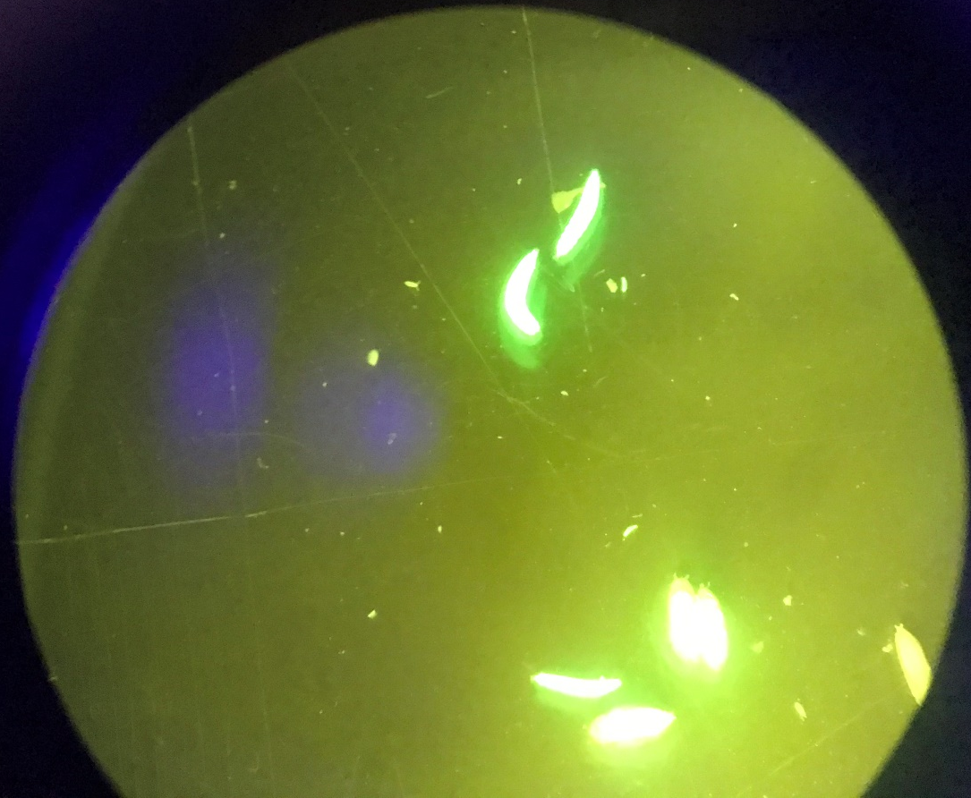
And with magnification of one larva see below for one larvae moving as compared to one held still on double stick tape placed on a microscope slide and with a higher magnification.

Expression of GFP can also be observed in pupae instead of larvae. The muscle expression with the MHC- GFP is seen below.

Preparations Needed by the Instructor
Materials needed for LED Assembly*
- Side-emitting LED (Blue light - 460nm minimum and 490nm maximum)
- Small heat sink
- 10x ocular objective lens (ensure it is wide enough for heat sink to fit inside)
- Two 6-inch pieces of electrical wire (preferably in different colors)
- Heat sink glue
- Electrical tape
- 9V battery
- 9V battery snap connector
- Solder
*Note: These materials can be found at ledsupply.com or on Amazon.

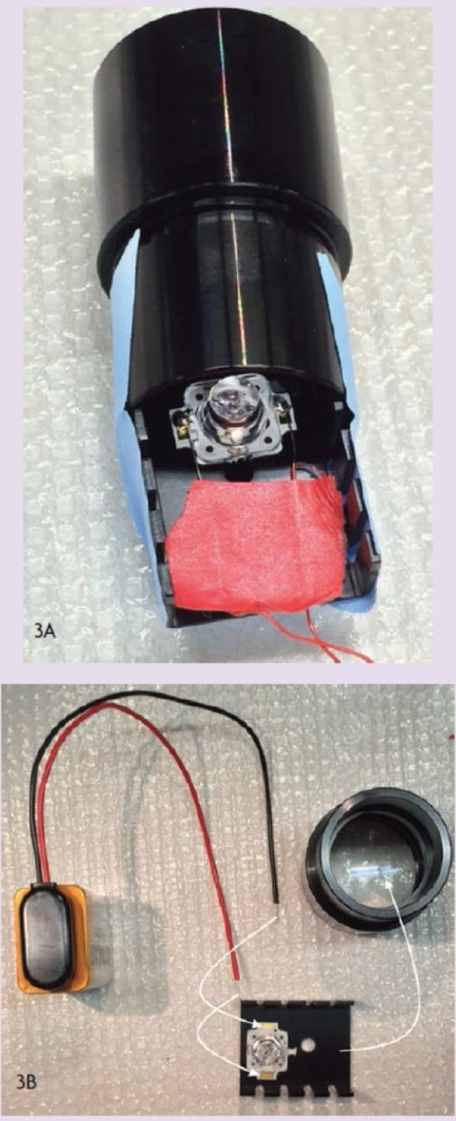
Directions for LED Assembly
- Before beginning the soldering process, determine which lead on LED is positive and which is negative. The LED will have markings (+/-) that specify which is which. Using a soldering iron and solder (found in most physics labs), solder one end of the electrical wires onto the LED. Using different colors will assist with keeping track of which wire is connected to the positive lead and vice versa.
- Solder the battery snap connector wires to the loose ends of the wires. Ensure the poles on battery connection match with LED +/-.
- Place electrical tape over the area where the wires have been soldered together to prevent contact with other metal objects.
- Using heat sink glue, attach the back of the LED to the heat sink.
- Place the heat sink device into the back of a 10x eyepiece objective, which will allow the light beam to be focused.
- Attach the battery.

Using ATR
Storage Information: ATR (500mg; available from Sigma-Aldrich, St. Louis, MO, USA) is dissolved in 17.6 ml absolute ethanol to make 100mM stock solutions. Then, 100µl of 100mM stock solution is transferred to small tubes, wrapped with aluminum foil and kept in a -20°C freezer. The ATR should be stored in a dark environment to avoid degradation due to light exposure.
***Purchasing Information: Fly food can be made or can be purchased in packets.
https://bdsc.indiana.edu/information/recipes/bloomfood.html
Preparation of fly food supplemented with ATR: In order to prepare fly food supplemented with 1mM ATR, 10ml fly food is dissolved in the microwave. The food is left to cool, then 100µl of 100mM ATR is mixed well with the fly food, or 100µl of absolute ethanol is mixed with food as a control. The food vial should be wrapped in aluminum foil and the food left until solidified (flies may stick to wet food).

Inheritance of the mhc-GFP transgene will be observed as dominant. When crossed with a strain that lacks the transgene, F1 progeny will all bear one copy, so it should be fluorescent. For the F2 progeny of an F1 sibling intercross, it is expected that 75% of larvae should have at least one copy of the transgene and show fluorescence.
Schematic illustration of the expected results of two generation intercross of a GAL4 driver (GAL-24B shown) with the UAS-ChR XXL optogenetic responder is shown below. The transgene inheritance is dominant for each, but a larva must have at least one copy of each transgene to display the paralysis behavior. This epistatic relationship should give rise to 9/16 of progeny in the F2 generation that show the behavioral trait.
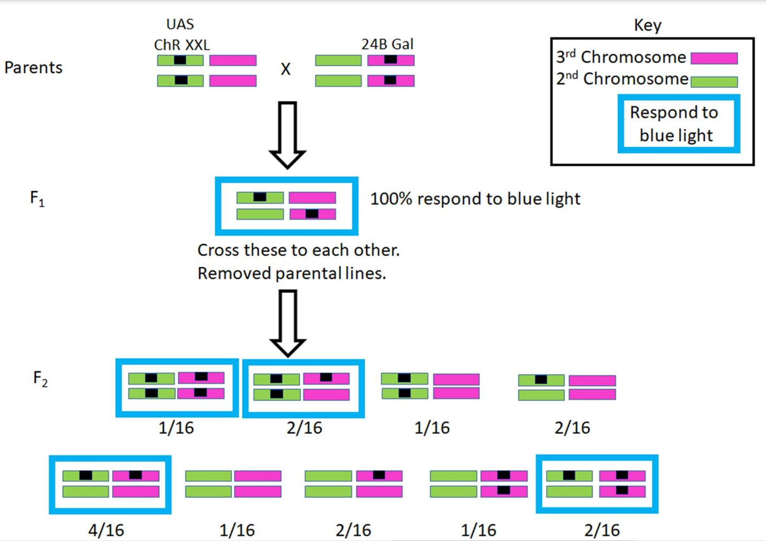

Cited References
Bradforth SE, Miller ER, Dichtel WR, et al.: University learning: Improve undergraduate science education. Nature. 2015, 523(7560): 283–284.
Branicki W, Liu F, van Duijn K, Draus-Barini J, Pośpiech E, Walsh S, Kupiec T, Wojas-Pelc A, Kayser M. Model-based prediction of human hair color using DNA variants. Hum Genet. 2011, 129(4):443-54. doi: 10.1007/s00439-010-0939-8.
Commo S, Gaillard O, Thibaut S, Bernard BA. Absence of TRP-2 in melanogenic melanocytes of human hair. Pigment Cell Res. 2004, 17(5):488-97.
Dawydow A, Gueta R, Ljaschenko D, Ullrich S, Hermann M, Ehmann N et al. Channelrhodopsin-2-XXL, a powerful optogenetic tool for low-light applications. Proc Natl Acad Sci. 2014, 111(38): 13972–13977.
Han J, Kraft P, Nan H, Guo Q, Chen C, Qureshi A, Hankinson SE, Hu FB, Duffy DL, Zhao ZZ, Martin NG, Montgomery GW, Hayward NK, Thomas G, Hoover RN, Chanock S, Hunter DJ. A genome-wide association study identifies novel alleles associated with hair color and skin pigmentation. PLoS Genet. 2008, 4(5):e1000074. doi: 10.1371/journal.pgen.1000074.
Ito S, Wakamatsu K. Diversity of human hair pigmentation as studied by chemical analysis of eumelanin and pheomelanin. J Eur Acad Dermatol Venereol. 2011, 25(12):1369-80. doi: 10.1111/j.1468-3083.2011.04278.x.
Majeed Z, Koch F, Morgan J et al. A novel educational module to teach neural circuits for college and high school students: NGSS-neurons, genetics, and selective stimulations. F1000Research 2017, 6:117 (https://doi.org/10.12688/f1000research.10632.1

Pulver SR, Hornstein NJ, Land BL, et al.: Advances in Physiological Education. 2011; 35: 82–91.
Titlow J.S., Anderson H., & Cooper R.L. (2014). Lights and Larvae: Using optogenetics to teach recombinant DNA and neurobiology. The Science Teacher National Science Teacher Association, 81, 3–9.
Acknowledgments
Funded by Department of Biology, University of Kentucky for laboratory supplies and personal funds of Robin Cooper for attending ABLE and presenting the module. We appreciate the editorial comments by Ms. Dara Buendia Castillo (Department of Biology, University of Kentucky)

About the Authors
Jeffrey Chalfant is a Ph.D. student in the Department of STEM Education at the University of Kentucky. He received a M.S. in Biology from the University of Kentucky in 2020 where he conducted research on the effects of circadian disruption on cardiovascular disease. He now studies how students construct and ask scientific questions.

Robin Cooper is an instructor of animal physiology and neurophysiology at the University of Kentucky. He has been at the University of Kentucky since 1996.
Tawny Aguayo-Williams is a secondary biology teacher at West Jessamine High School in Nicholasville, Kentucky. She received a B.S. in Biology from Alice Lloyd College in 2014 and a M.A. in Secondary STEM Education from University of Kentucky in 2020.

Lexie Holtzclaw is attending Morehead State University (Kentucky) and majoring in Biomedical Science.

Madison Loveless is attending Lindsey Wilson College double majoring in psychology and Human Services

Jennifer Wilson is a science teacher at Pulaski County High School in Somerset, Kentucky. She has been part of Project Lead the Way Biomedical Sciences and have taught for 21 years.

Doug Harrison has been an instructor in genetics, developmental biology, and cell biology courses at the University of Kentucky since 1996. He has conducted research using Drosophila as a model system for over 35 years.

